Name: _________________________________________ Period: _________
CARNEGIE ONLINE INSTRUCTIONS
Login to the Computer
- For the username, type nIDNumber (Your ID Number). Example: n808000
- For password type: ABcd12
- The computer will ask you to change your password. It must be 7 characters or longer, have a capital letter and have a number. Example: Hotdog9

Please write your password down: ______________________________
Login to Carnegie Learning Online
- Click on the North Carnegie icon OR go to an internet browser and type the web address: online.carnegielearning.com
- Enter in the following information. Your username will be given by your instructor.
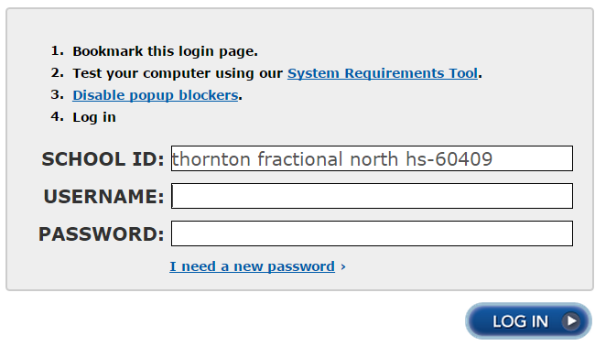
Type the School ID into the box!
thornton fractional north hs-60409

FOR FIRST TIME USERS: Please click ‘I need a new password’ and create a password for the website. Please choose one you will remember. Then log into the program with your username and password.
- Once you are logged in, a screen with three blue bars will come up. Click on the top bar – Cognitive Tutor Prime.
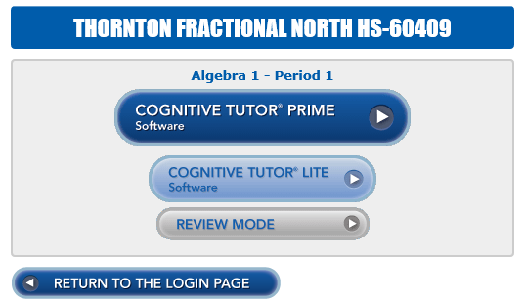

Another window will appear. Please wait for the program to load and start working
Keep this in your math binder for reference!

