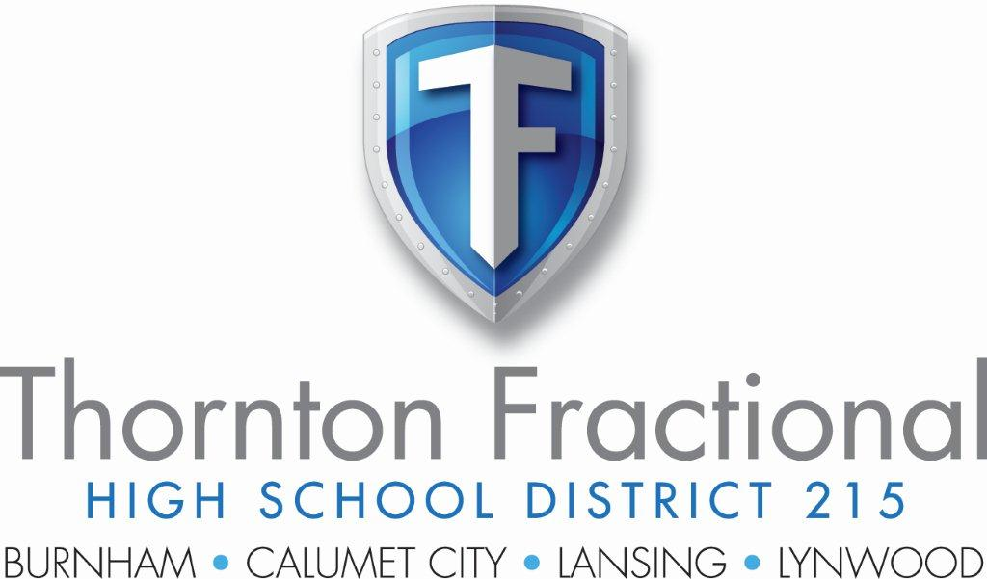

**ESSER III**

**Use of Funds**

**Updated 10.10.2023**

**Thornton Fractional High School District 215**

**American Rescue Plan (ARP) ESSER III Use of Funds**

**Philosophy & Protocols**

District 215 fully appreciates the award of $9,538,859 in ESSER III funding to help our district combat the negative effects of the COVID-19 pandemic. Isolation and remote learning have resulted in many issues which negated the academic growth of our students.

To that end, District 215 planned our original ESSER 3 application expenditures carefully. Multiple themes were developed and detailed plans on how to use the funds to achieve these objectives were thoroughly discussed and delineated in detail in our grant application.

The major theme areas that emerged are: 1)Building/Capital Projects; 2)Technology; 3)Summer enrichment; 4)After School Programs; 5)Address Instructional gaps; 6)Social Emotional; 7)Other. The two largest areas were Addressing Instructional Gaps and Building/Capital Projects. Each comprised 38% of the grant allocation, for a total of 76% in these 2 areas.

The stakeholders formulated our plan to be consistent with CDC and local health department guidance, effective in addressing instructional and social emotional gaps, increasing technology, and providing for building services/improvements that focused on sanitation, air quality, creating more classroom space, technology, etc.

The timeline for our process is listed below:

9/1/21 Initial draft to Cabinet. Discuss draft, gather feedback from Cabinet members, brainstorming session with the Departments of Teaching & Learning and Student Services & Equity.

9/15/21 Discuss any additional ideas. Leave Cabinet meeting with final ideas to incorporate into draft for public comment. Reach out to Union leadership with draft and solicit input.

9/20/21 Post draft on website. Invite the public to comment. Email parents through School Messenger to inform them plan is posted.

10/4/21 Last day for Public comments.

10/13/21 Discuss plan at Committee of the Whole. Also disclose all public comments, but not the persons behind the comments. Leave meeting with final changes to incorporate into the spending plan. Set the Public Hearing date for October 26.

10/26/21 Public Hearing. Obtain Board approval to move forward with grant submission.

Our grant was approved in December 2021. District 215 immediately began to put the funding to work.

As we’ve worked through the process, we have tweaked some of our plan. We discovered that much more needed to be addressed in the realm of Social Emotional student needs & HVAC concerns. Below is a chart showing our original application, amended application (draft), amount spent through 6.30.23, and the balance remaining as of that date. The entire grant must be spent by June of 2024. ***More detail on each expenditure type item is listed after the chart***.



**Expenditure type categories – additional information**

This section serves to provide the reader greater detail on the specific types of budgeting/spending listed in the chart on the previous page.

**Building/Capital Projects**

1. Capital Projects Improvements
   1. Natatorium HVAC replacement at TF North (to be completed summer 2023 or 2024)
   2. TF South Gymnasium HVAC replacement (to be completed summer 2023)
   3. Video Surveillance upgraded and completely replaced districtwide (completed summer 2022)
   4. Partial replacement of TF North domestic water system & some toilet room remodel (to be completed summer 2023)
   5. New double oven & steam cabinet purchased at TF North (completed spring 2022)
2. Custodial Services
   1. One additional custodian at North and one at South were added in FY ’22. This aided in the process of keeping the building clean and sanitized, especially the cafeteria areas.
3. PPE
   1. Various PPE (hand sanitizer, masks, sneeze guards, etc.) were purchased at all 3 campuses to ensure adherence to COVID-19 protocols and enhance student & staff safety.
4. HVAC repairs/air quality
   1. The District was able to address HVAC failures in a timely manner. This ensures the District is maintaining adequate air quality and circulation throughout the building in compliance with COVID-19 protocols.

**Technology**

1. Infrastructure Improvements & Software
   1. Network and datacenter infrastructure (servers, storage backup equipment & software, protection for data in online services, cloud hosted backup service, & installation, network core & access switches, cloud hosted server/network infrastructure)
   2. Security software & licensing (endpoint protection, software licensing, hardware & software for multi-factor authentication, network firewall, anti-malware licensing, network monitoring software).
   3. ZOOM fee
2. Chromebooks/Filtering Software
   1. 1200 Chromebooks budgeted for cyclical student chromebook replacement (May 2024)
   2. Chromebook content filtering software
   3. Incident IQ – tech & custodial automated ticketing software

**Summer Enrichment**

1. Summer programs offered at all 3 campuses – 3 years budget. A variety of enrichment programs including Literacy, College & Career Writing Skills, Math, Social Emotional Wellness groups, Physical Fitness, Music/Art Appreciation, Mentoring.

**After School Clubs**

1. After School Clubs at all campuses catering to a wide variety of interests including Wellness/Fitness, Peer Mentoring, Music/Art Appreciation, Civics, Student Advocacy
   1. Esports after school program & club at North & South started & funded through these funds
   2. Student Equity & Leadership club student presentation and attendance at an Equity Conference out of State (students invited to present at a conference)
   3. Speech team at North – attendance at Nationals

**Address Instructional Gaps**

1. Instructional support/tutoring (in person) for students struggling academically
2. Paper software (student on-line tutoring program) for students available 24-7, 7 days weekly in all school subjects. Students receive live, interactive tutoring and homework assistance on demand.
3. Replace textbooks lost during the pandemic; also curriculum adoptions in multiple areas to address the needed rigor and update of our academic programs
4. Educational software
5. Creation & expansion of CTE offering including Barbering, Cosmetology, A/P classes, Electrical, Entrepreneurship
6. Spanish interpreter/Family Outreach position (interpret for IEP, etc.; outreach to families)
7. College level courses for students at South Suburban College
8. College level courses for students – National Equity Lab
9. Homebound instruction
10. Diagnostic assessment tool (NWEA)
11. Mentoring Program for teachers

**Social Emotional**

1. SEL counseling services for 2 years – all campuses
2. Project Wayfinder SEL curriculum
3. Dean’s office incentives for students
4. CPI training for teachers
5. Cultural Competency & Instructional Strategies training
6. Affinity group formation & facilitation
7. Family Outreach effort to foster academic dialogue and promote student participation in school based activities
8. SRO at North and South campuses
9. Counseling program for students & families (after school)

**Other**

1. Vaccine incentive
   1. Student Covid-19 ambassador pay
   2. Vaccine incentives (gift cards, dances, etc.)
2. Student Peer Advisory Board – restorative practices training
3. Equity initiatives (new teacher recruitment & retention)